Troubleshooting Wireless cards in the Windows 9x through 2000 environment.
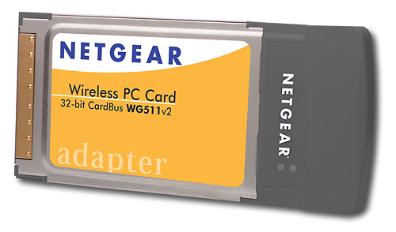
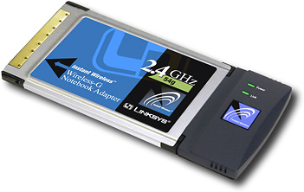
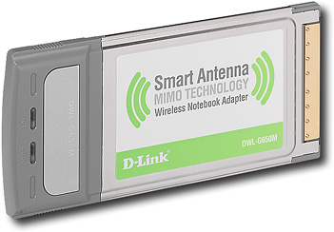
df
Built in Wireless cards

Windows 2000 and the Intel Pro wireless 2100 adapter
- Open Intel Proset (found in Control Panel)
- Make sure the Intel Pro Wireless 2100 adapter is listed in general tab (hhonors may also be listed as network name, but no network profile will be listed);
- Click on Network tab;
- Click on Scan button;
- Will find hhonors (or HSIA) ssid, click on Connect button;
- Will ask if you want to create a profile, click yes;
- First screen will ask for a name (any will do, though I use Hilton Hotel), also select infrastructure from this screen, click Next;
- Make sure Authentication is 'open' and WEP 'disabled,' click Finish;
- Open IE, should connect.
Generic built in wireless cards Windows 2000

1. Click on Start , then Settings , then Network Dial-up Connections.
2. Find the Local Area Connection that applies to youe 802.11b wireless adapter. Right clisk on its icon and select Properties.
3. Click on Configure just below the network adapter.
4. Click on the Adavanced tab. Highlight Network Name and type the SSID in the field to the right OR
Click on the Settings tab, select 802.11b SSID , and type the SSID in the field on the right.
5. Click OK on the adapter properties screen.
6. Click OK on the Local Area Connection Properties screen.
7. Restart your computer if prompted to do so.

Generic built in wireless cards Windows 98 and ME

1. Double Click on My Computer.
2. Double Click on Control Panel.
3. Double Click on Network.
4. In the Network view select your 802.11b network adapter.
5. Click on Properties
-Select the Advanced tab, select SSID, and type the SSID in the field on the right. OR
-Select the Settings tab and type the SSID in the SSID field. OR
-Select the Basic tab and enter the SSID in the field asking for the network name.
6. Click OK on the adapter screen.
7. Click OK on the Network Properties screen.
8. Restart your computer.

PCMCIA wireless cards

Linksys
- Double click on the WLAN Monitor Icon next to the clock on the “Start” bar.
- When the “WLAN Monitor” loads, click onto the Profiles tab.
- After the “Profiles” area loads click on Default under the “Profile” area, then click on the Edit button.
- On the “Choose a network Type” screen, select either Infrastructure Mode or AdHoc. If a Wireless Access Point or Wireless router, be sure to use Infrastructure. If a wireless network without a Wireless Access Point or Wireless router is being used, then select the AdHoc Mode option.
- Input the SSID that the wireless network uses or will be using, into the “SSID” field (the default SSID for all Linksys wireless devices is linksys), then click the Next button.
  - The ”AdHoc Mode Settings” screen will appear if you selected AdHoc. You will need to set the “Channel” to the same channel as the rest of your network; the default channel for all Linksys Wireless Adapters is 6. Additionally, if the adapter is 802.11g, then the “Network Mode” will also need to be selected (Linksys recommends leaving it in Mixed Mode), then click the Next button.
- When the “Network Settings” screen loads, set the adapter to either Obtain an IP address automatically (DHCP) or Specify the address. If the network has a router on it, or if unsure, it is usually best to use Obtain an IP address automatically (DHCP).
- After select the proper Network Settings, click the Next button.
- The “Security Settings” screen will appear next. If the Wireless Network is using WEP encryption, please see Answer ID 1422. If the Wireless Network is not using WEP encryption, leave the “WEP” option Disabled and click on the Next button.
- When the “Confirm New Settings” window appears, click the Next or Yes button.
- The “Congratulations” screen should appear next, click on the Activate New Settings Now button.
- Restart the computer and the setup is finished.
D-link
Step 1 Double-click the bar graph icon in the system tray (the area in the lower right-hand corner of the screen, by the clock).

Step 2 Click Site Survey on the left side and select the SSID of your wireless access point or router on the right side and then click Connect.
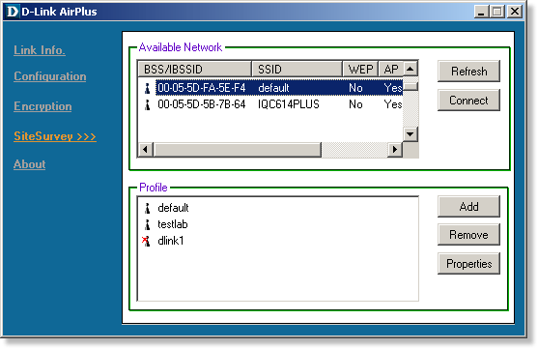
Step 3 Click OK.
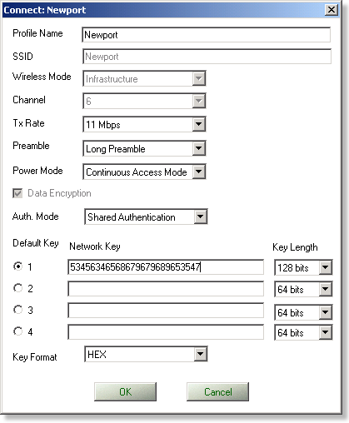
Step 4 You will be able to view your link status in the Link Info window.
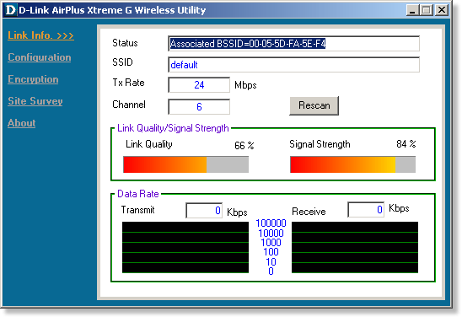

Cisco
- Windows ACU Configuration ('98, 2000, NT, ME, XP)
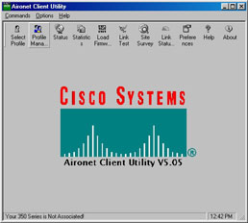
Fig. #1 - Cisco Aironet Client Utility Main Screen
- After you've installed and opened the Aironet Client Utility (ACU), fig. #1 will appear. First, click on the "Profile Manager" button in the ACU to create a "profile". This will define the parameters to be used in order to access a wireless network, whether at NYU, at your home, at Starbuck's, etc. (see Screen #1).
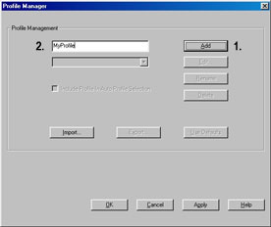
Fig. #2 - Profile Manager
- On the new window that appears, click on the "Add" button (step 1 in fig. #2);, then, in the field to the left of the "Add" button that can now be edited, enter a name for your profile, i.e., Me at Home, My NYURoam, etc. (step 2 in fig. #2). In the example here, the client name is "MyProfile", but it can be any name you'd like. You can create and save up to 16 profiles. Once you've entered your profile name, click "OK".
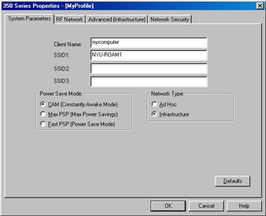
Fig. #3 - Systems Parameters Tab
- Fig. #3 now appears. A default "Client Name" is generated by the ACU client. You can keep it or create your own. In the example here, we erased the default client name and changed it to "mycomputer". All Cisco users on the NYURoam network should then type NYU-ROAM1 in the SSID1 field, as it appears in Screen #3 below. Leave the other two SSID fields blank.
- Note the "Power Save" mode options, which impact the battery life of your portable when using wireless. Select the option you think will best meet your needs. You can switch modes later, if desired.
  - CAM - is the mode for machines where power consumption is not an issue. It keeps wireless powered up all the time, so there is little latency for responding to messages. This mode is recommended for devices where high availability is desired.
  - Max PSP - is recommended for devices where power consumption is a major concern. It causes the Access Point (the wireless device you interface with) to buffer incoming messages for your wireless NIC, which must wake up periodically and poll the Access Point to see if there are any buffered messages waiting for it. The wireless NIC can request each message and then go back to sleep.
  - Fast PSP - is a blend of CAM and PSP modes. Fast PSP mode switches between PSP and CAM based on network traffic. When receiving a large number of packets, Fast PSP Mode will temporarily switch to CAM mode to retrieve the packets. Once the packets are retrieved, it switches back to PSP mode.
The "Network Type" setting should remain in "Infrastructure" mode (the default setting). Next, click on the "RF Network" tab at the top of the screen.
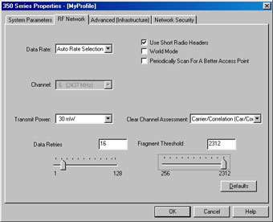
Fig. #4 - RF Network Tab
In the RF Network tab window (see fig. #4), change the "Transmit Power" level, which is set to 100 mW, to 30 mW. Also, disable the "Periodically Scan For A Better Access Point" setting (its default setting is enabled). All other settings should remain the same.
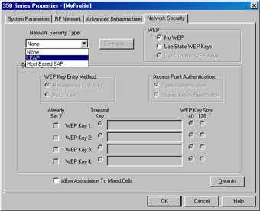
Fig. #5 - Network Security Tab
Next, skip over the Advanced (Infrastructure) tab and click on the "Network Security" tab instead. In the "Network Security Type" field, change "None" to "LEAP". Then click on the "Configure..." button (see fig. #5).
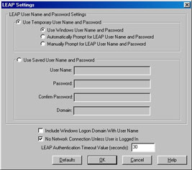
Fig. #6 - LEAP Settings
The LEAP Settings window will open, allowing you to determine how you will sign on to the wireless network (fig. #6). Your options are in the first panel; choose the one that you prefer:
  - Use Windows User Name and Password - This option uses the NYU NetID and the password that you enter to login to NYUHome.
  - Automatically Prompt for LEAP User Name and Password - This option causes a LEAP login box that prompts you to type in the LEAP User Name and Password.
  - Manually Prompt for LEAP User Name and Password - This option allows you to click on the "Manual LEAP Login" menu item in the commands menu to bring up the LEAP login box.
We strongly recommend that you do NOT use the "Use Saved User Name and Password" option, since your NetID and password will be saved on your machine, which is a serious security risk.
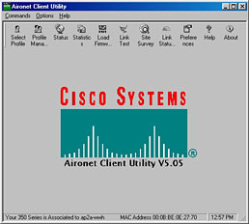
Fig. #7 - Cisco Aironet Client Utility Main Screen (Associated)
Finally, disable the "Include Windows Logon Domain With User Name" option, which is enabled by default. Click on "OK" to return to the "Network Security" tab. Then click "OK", and "OK" again. Now you're back to the main ACU screen. Note that if you're in the vicinity of an NYURoam Access Point, the bottom of the ACU screen will show that you are now "associated" (connected). See fig. #7.
Click on the "Select Profile" icon in the top left corner of the main ACU window. The profile you just created will be selected by default. You can select from multiple profiles here if you use wireless in other locations. Click "OK".
In the Commands pulldown menu, select "Manual LEAP login..." The LEAP sign-on panel appears. Enter your NetID in the "User name" field and your NYUHome password in the "Password" field. Then click "OK".
You will see the login progress flicker by. Once authenticated onto the network, your machine acquires an IP address and you are connected.
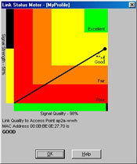
Fig. #8 - Link Status
You can always check on your radio connection status by clicking on the "Link Status" button, which gives you a graphical display of your signal strength and quality (see Fig. #8).
2 Wire
To configure, go to Start -> Programs -> 2Wire Gateway -> Wireless Client Manager.
Result: The 2Wire HomePortal (wireless) Client Manager displays

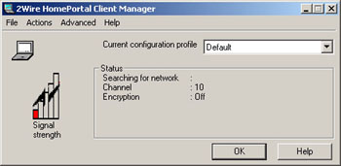

Configure the wireless connection by clicking Actions -> Add/Edit Configuration Profile

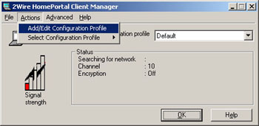

The profile name can be changed (the profile name may be up to 29 characters in length) or left as default. Set the Network Type field to Access Point. Click Next

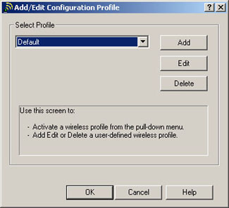

The network name must contain the SSID of the 2Wire HomePortal. Click Scan to display a list of available networks. Select the 2Wire HomePortal to which you are connecting. Click OK.
Result: The Network Name field is populated with the SSID of the 2Wire HomePortal.
Note: The default setting for the network name or SSID is 2WIREnnn. The SSID is case sensitive and WIRE is all capital letters. Replace the last three characters of the SSID (nnn) with the last three digits of the serial number found on the bottom of the 2Wire HomePortal.
It is possible to change the default SSID on all versions of the 2Wire HomePortal software, and it is possible to disable SSID broadcasting on software versions 3.5.x and higher.
Click Next to display the Set Security dialog.

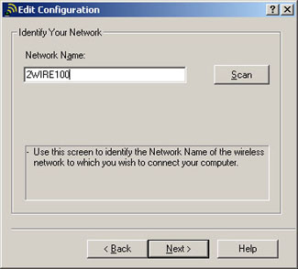
Select the Enable Data Security box. Select the Use Hexadecimal (0-9, a-f, A-F) radio button. In the Key 1 field, enter the 10-digit wireless encryption key found on the bottom of the 2Wire HomePortal, under the bar code, between brackets ([0123456789]). Select Key 1 from the Encrypt Data with field. Click Next.

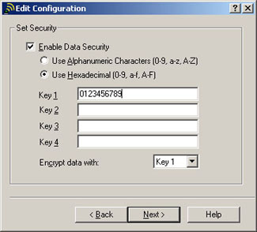

Select a power management option. Click Next.
Note: Turning Power Management Off uses slightly more power but yields better performance. This is the recommended option on a desktop computer or on a laptop that is either far away from the HomePortal and/or generally operated on A/C, rather than battery power. Power Management On uses less power to extend battery life of a laptop computer but results in slightly less range.

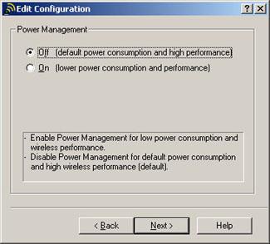
Select Renew IP address when selecting this profile. Click Finish .Note: Newer versions of the Client Manager Utility will not display this option

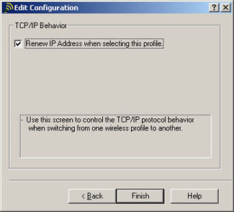

The Add/Edit Configuration screen of the Wireless Client Manager will come up.
Click OK.

Before returning to the main Wireless Client Manager screen, the TCP/IP Updating IP address screen may display.

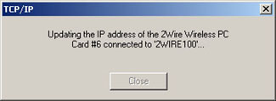

The 2Wire Wireless Client Manager Screen will display the connected network information and signal strength. Click OK to close the window.

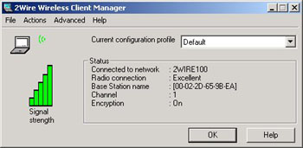

Radio antenna buttons
Here are the radio switches and buttons that I know of:

Toshiba – physical switch on the side (Fn + F8 will display the status of the switch)
Dell & Gateway – Fn + F2
IBM – Fn + F5
Compaq – button on the top of the keyboard
Fujitsu – physical switch
Sharp – Fn + F1
Sony – switch
HP – button (not always easily found)

